**|| श्री ||**

**Shubhamrut Designing Studio**

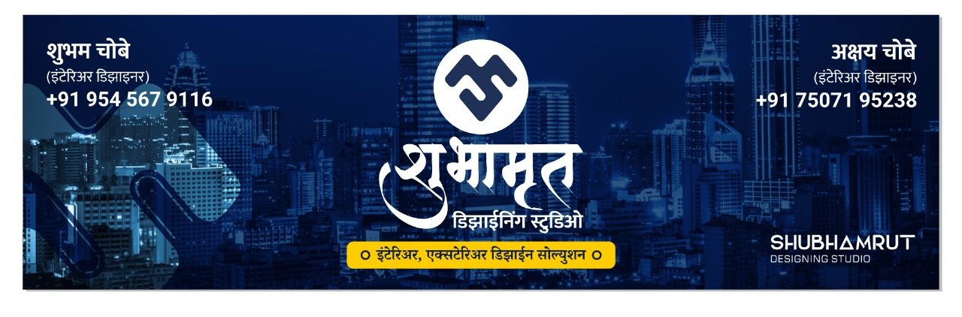

**Requirement gathering : (21 – 1 – 2025)**

**General Requirements**

1. **UI/UX Design:**
   * **A neat, clean, and modern user interface.**
   * **Navy blue color palette.**
   * **Fully responsive design for all devices (desktop, tablet, mobile).**

**Pages and Features**

1. **Home Page:**
   * **Background video playing automatically.**
   * **As the user scrolls down:**
     + **Social media links (icons).**
     + **Additional information about the company.**
2. **Walkthrough Page:**
   * **Auto-playing YouTube videos.**
   * **Linked videos from Youtube**
   * **Multiple videos displayed as the user scrolls down.**
3. **Projects Page:**
   * **Displays all projects with a single representative photo and basic information.**
   * **Clicking on a project opens a Show Project Page:**
     + **Multiple images of the project.**
     + **Detailed information about the project.**
4. **Gallery Page:**
   * **Includes all projects (already completed and designs).**
   * **Filter functionality:**
     + **Categories: Floor plan , Cut section, 3D elevation, Interior design**
     + **Types: Interior, Exterior.**
   * **Sliding video section at the top showcasing completed projects (specialties).**
5. **Contact Page:**
   * **Contact form for visitors to connect with the admin.**
   * **Google Maps integration for location display.**
   * **Social media icons for direct links to profiles.**
6. **About Us Page:**
   * **Contains information about the company, its mission, and vision.**
   * **May include an image or video section.**

**Requirement Gathering for the Website**

**General Requirements**

1. **UI/UX Design:**
   * **A neat, clean, and modern user interface.**
   * **Navy blue color palette.**
   * **Fully responsive design for all devices (desktop, tablet, mobile).**

**Pages and Features**

1. **Home Page:**
   * **Background video playing automatically.**
   * **As the user scrolls down:**
     + **Social media links (icons).**
     + **Additional information about the company.**
2. **Walkthrough Page:**
   * **Auto-playing YouTube videos.**
   * **Linked videos fetched dynamically from the database.**
   * **Multiple videos displayed as the user scrolls down.**
3. **Projects Page:**
   * **Displays all projects with a single representative photo and basic information.**
   * **Clicking on a project opens a Show Project Page:**
     + **Multiple images of the project.**
     + **Detailed information about the project.**
4. **Gallery Page:**
   * **Includes all projects (already completed and designs).**
   * **Filter functionality:**
     + **Categories: Residential, Commercial.**
     + **Types: Interior, Exterior.**
   * **Sliding video section at the top showcasing completed projects (specialties).**
5. **Contact Page:**
   * **Contact form for visitors to connect with the admin.**
   * **Google Maps integration for location display.**
   * **Social media icons for direct links to profiles.**
6. **About Us Page:**
   * **Contains information about the company, its mission, and vision.**
   * **May include an image or video section.**

**Admin Features**

1. **Creation Form:**
   * **Allows admin to upload:**
     + **Multiple images.**
     + **Project information.**
     + **Categories for projects (e.g., floor plan, cut section, 3d elevation interior design).**
   * **Uploaded data stored in the database and displayed dynamically on the website.**
2. **Admin Panel:**
   * **Edit/Delete functionality:**
     + **Projects.**
     + **Gallery designs.**
   * **User-friendly interface for managing website content.**

**Technical Features**

1. **Dynamic Content:**
   * **All content (projects, gallery, videos, etc.) fetched from a database.**
2. **Backend Integration:**
   * **Database to store project details, images, videos, and categories.**
   * **Form validation for uploads and contact forms.**
3. **Video Integration:**
   * **YouTube links embedded dynamically on the walkthrough and gallery pages.**

**Cost Estimation**

**I. Features and Effort Estimation**

**1. Home Page**

* **Requirements:**
  + **Responsive design with a modern navy blue UI.**
  + **Background video autoplay.**
  + **Social media links and other elements.**
* **Effort: ~15-20 hours.**

**2. Walkthrough Page**

* **Requirements:**
  + **Autoplaying YouTube videos.**
  + **Dynamic video links fetched from the database.**
* **Effort: ~15-20 hours.**

**3. Projects Page**

* **Requirements:**
  + **Show all projects with an image and basic details.**
  + **On click, show a detailed page with multiple images and project details.**
* **Effort: ~20-25 hours.**

**4. Gallery Page**

* **Requirements:**
  + **Responsive grid layout with filters (e.g., residential/commercial, interior/exterior).**
  + **Sliding videos at the top.**
* **Effort: ~20-25 hours.**

**5. Creation Form (Admin Panel)**

* **Requirements:**
  + **Admin can upload images, project details, and categories.**
  + **Data stored in the database and displayed dynamically.**
* **Effort: ~25-30 hours.**

**6. Admin Panel**

* **Requirements:**
  + **Edit/delete functionality for projects or gallery designs.**
* **Effort: ~15-20 hours.**

**7. Contact Page**

* **Requirements:**
  + **Contact form with form validation.**
  + **Map integration.**
  + **Social media icons.**
* **Effort: ~10-15 hours.**

**8. About Us Page**

* **Requirements:**
  + **Simple text and image content.**
* **Effort: ~5-10 hours.**

**II. Total Development Effort**

* **Frontend Development: ~75-90 hours.**
* **Backend Development: ~30-40 hours.**
* **Testing and Debugging: ~15-20 hours.**
* **Total Effort: ~120-150 hours.**

**Revised Total Effort Estimation:**

* **Home Page: 15-20 hours**
* **Walkthrough Page: 15-20 hours**
* **Projects Page: 20-25 hours**
* **Show Project Page (User + Admin): 20-30 hours**
* **Gallery Page: 20-25 hours**
* **Creation Form (Admin Panel): 25-30 hours**
* **Admin Panel: 15-20 hours**
* **Contact Page: 10-15 hours**
* **About Us Page: 5-10 hours**